Name: Grade:
Period:
Refraction/ Snell’s Law Quiz

1. Refraction occurs when light waves travel from one medium to another because the ____________ of the light waves changes.
A. frequency
B. color
C. amplitude
D. speed

2. The following diagram represents a ray of light traveling from medium 1 into medium 2. In medium 2, the ____________ of the ray is ____________ than it was in medium 1.
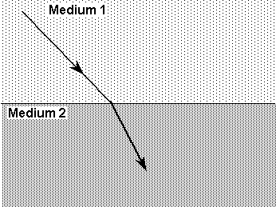
A. speed, slower
B. speed, faster
C. frequency, higher
D. frequency, lower

3. The index of refraction for a medium
A. is constant for that particular medium.
B. is the ratio of the speed of light in air to the speed of light in the medium.
C. increases as the speed of light in the medium decreases.
D. decreases as the speed of light in the medium decreases.

4. Suppose a person standing beside a swimming pool and a person under the water in the pool observe each other. Which of the following statements is correct?
A. The path of the light is different for each observer.
B. The person beside the pool appears closer to the pool.
C. The person in the pool appears farther away from the surface.
D. Neither person appears to be their true size.

5. A light ray passing through a transparent medium at an angle of 42.0° to the normal exits into water. If the index of refraction of the material is 1.49 and the index of refraction of water is 1.333, what is the angle of refraction in the water at the boundary?
A. 36.8°
B. 48.5°
C. 63.1°
D. 85.6°

6. A light ray passes from carbon tetrachloride into another medium. The angle of incidence is 54.0°, and the angle of refraction is 37.9°. What is the index of refraction of the medium? Use 1.461 as the index of refraction of carbon tetrachloride.
A. 1.93
B. 1.11
C. 0.903
D. 1.32

